WHEN IT RAINS, IT DRAINS. AND IT HAS TO GO SOMEWHERE

Water from inside our homes goes to a wastewater facility for purification.
But water from roofs, streets, and outdoor spigots goes untreated directly into storm drains – straight to our waterways – picking up all

kinds of contaminants along the way!

DID YOU
KNOW
Excess nutrients, specifically nitrogen and phosphorus, pollute stormwater run-off from urban areas, contributing to the third greatest cause of
lake deterioration in the US.

DID YOU

KNOW
The amount of phosphorus in grass clippings from mowing your lawn just once can produce up to
100 lbs. of unwanted algae
if it ends up in our lakes and ponds.

DID YOU

KNOW
Leaf “litter” and landscape trash accounts for 56% of phosphorus in urban stormwater, not to

DID YOU

Just one pound of fertilizer over-application on the average

mention clogging storm drains, causing
potential flooding and increasing debris in our waterways.

KNOW
lawn can equate to 34.2 lbs. of excess algae growth in streams and lakes.

DID YOU

KNOW
When you wash your car in the driveway, you’re washing about 120 gallons of
DID YOU

KNOW

If dog owners don’t clean up after their pooches,

grime-filled water downstream. The soap,
together with the dirt, grease and grime flows untreated into nearby storm drains, which runs directly
into lakes and streams.

WHY IT

MATTERS
390 million pounds of poop can wash into our waterways every year just in Colorado! Dog waste contains 10% phosphates and 2% nitrates,
contributing to algae growth.

Too many nutrients in streams and lakes cause rapid growth of algae.

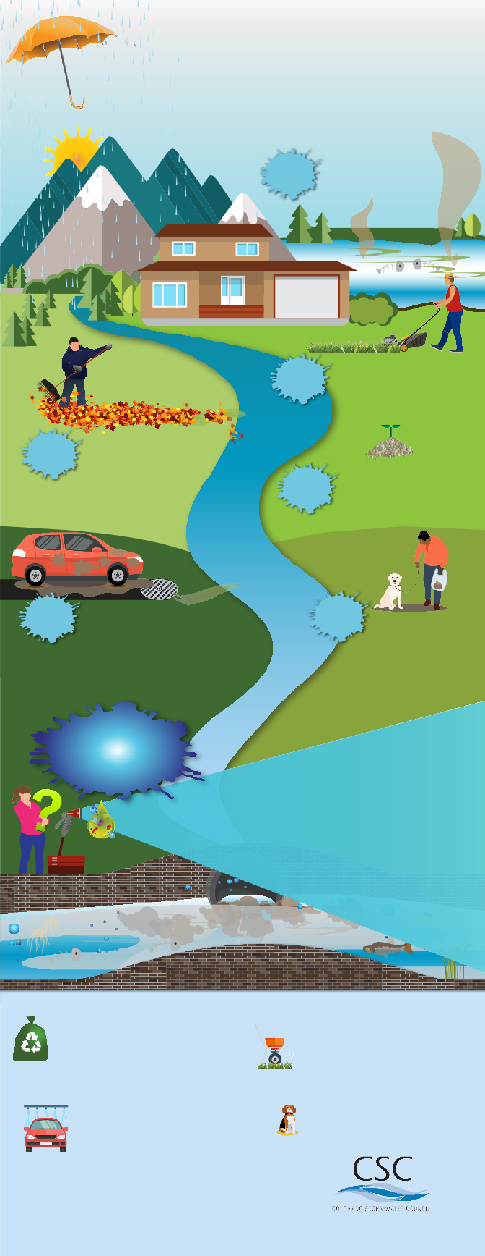
Algae looks bad, smells bad, degrades water quality
and can be harmful to your health.
As algae decays, it uses up oxygen in the water, leading to a decline in our
ter quality –
drinking wa
and makes it more expensive to treat.

WHAT YOU CAN DO
Dispose Properly
- Compost or bag your leaves and lawn clippings
- Don’t blow leaves or lawn clippings into the street
- Sweep up any spills or overspray of fertilizers on sidewalks or streets

recommendations. More isn’t better!
- Fertilizing in the early fall promotes healthy root systems – leading to stronger, more resilient lawns and plants
Fertilize Efficiently
- Always follow the manufacturer’s application

Be Car Smart
- Use a commercial car wash, where water is recycled and sent to treatment facilities
- Wash your car on the lawn or gravel
- Dump your soapy bucket in the sink
Pick It Up & Pitch It
- Clean up dog waste and dispose properly

For more information and tips to preserve our waterways, visit
colorado-stormwater-council.org

